**PROJECT REPORT**

**CAMP BI V3**

**BATCH 1 : GROUP 5**

**INDEX**

|  |  |  |  |
| --- | --- | --- | --- |
| **S. No.** | **Contents** | | **Page No.** |
| O1. | Project Description | | 02 |
| 02. | Unit Test Report | | 02 - 07 |
|  |  | Importing Source table | 02 |
|  |  | Importing Target tables | 03 |
|  |  | Mapping | 03 |
|  |  | Implementation of filter condition | 04-05 |
|  |  | Expression | 05-06 |
|  |  | Creation and Implementation of Aggregate function | 06 |
|  |  | Designing of Workflow | 07 |

**Supervised By**

***Mr. Pranay***

**Group Members :**

* Mr. Siddharth Rai
* Ms. Saurabh Pratap Singh
* Mr. Shubham Dixit
* Mr. Aryan Kaundal
* Mr. Rounak Raj Singh

***PROJECT DESCRIPTION***

The project involves data transformations using Informatica Power-Center.

* Steps involved in performing the Mapping:
  1. Mapping of source table and target table.
  2. Implementation of Aggregate function.
  3. Implementation of required transformation.
  4. Implementation of Update Strategy.

***UNIT TEST REPORT***

1. Importing ( Emp )into Source Analyzer.

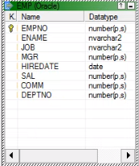

Fig: 01

1. Importing Target table ( Emp1 ) into Target Designer.

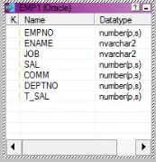

Fig: 02

3. Mapping

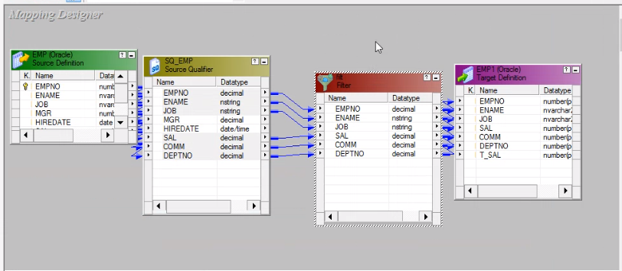

Fig: 03

1. Implementation of Filter conditions.



Fig: 04.1

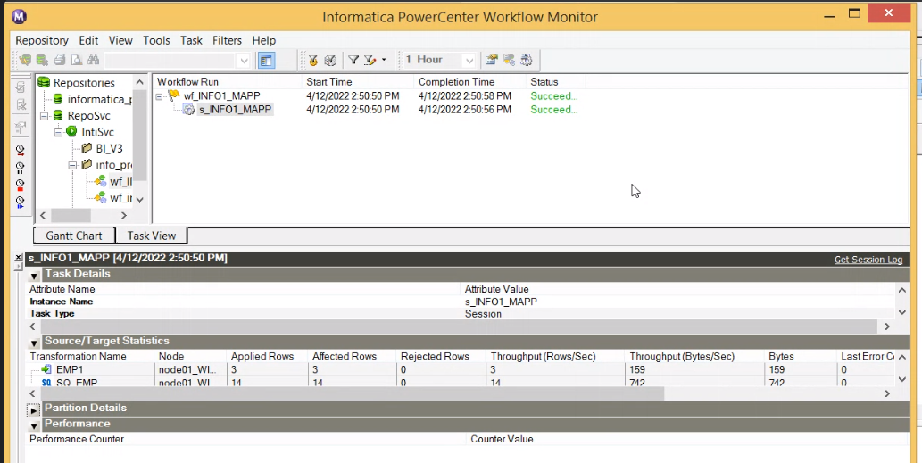

Fig: 04.2

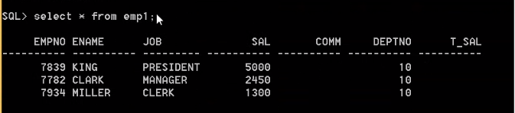

Fig: 04.3

1. Expression

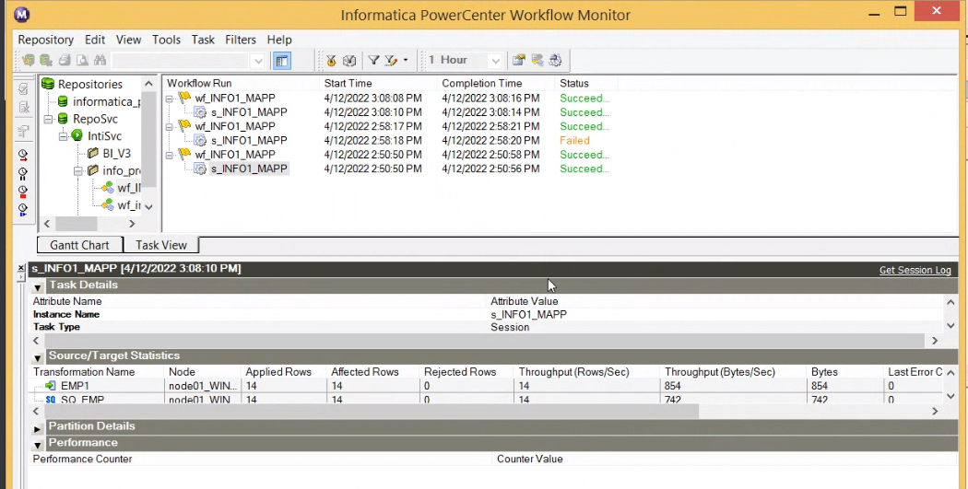

Fig: 05.1

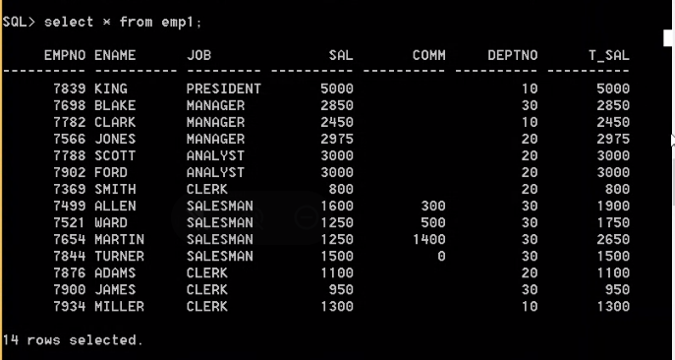

Fig: 05.2

1. Creation and Implementation of Aggregate function.

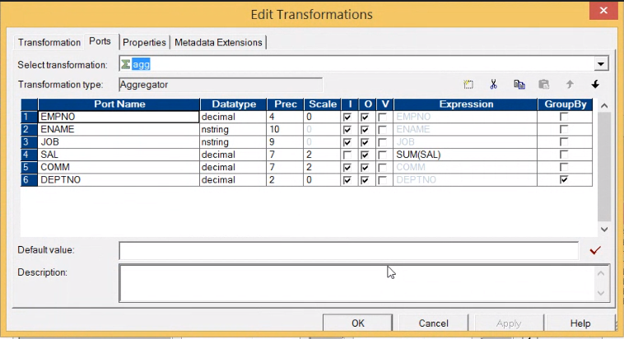

Fig: 06

7. Designing of Workflow.

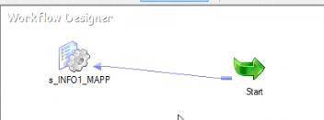

Fig: 07